ASSIGNMENT:-(02)

Q. (01) Create a database named university and a collection named students. Insert multiple student documents with fields: name, age, department, and grades.
Query use university
Query db. create Collection("student")
Query db. student. Insert Many ([
{name:"Alice",age:20 , department :"Computer science", grades:{"math":85,"english":92}},
{name:"Bob",age:21,department:"Physics",grades:{"math":88,"physics":90}},
{name:"charlie",age:22,department:"Mathematics",grades:{"math":95,"statistics":89}}])
Output
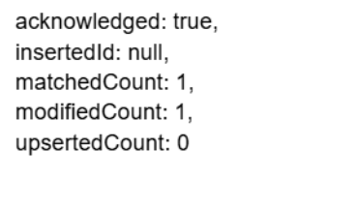
Query db. Student .find()
Output
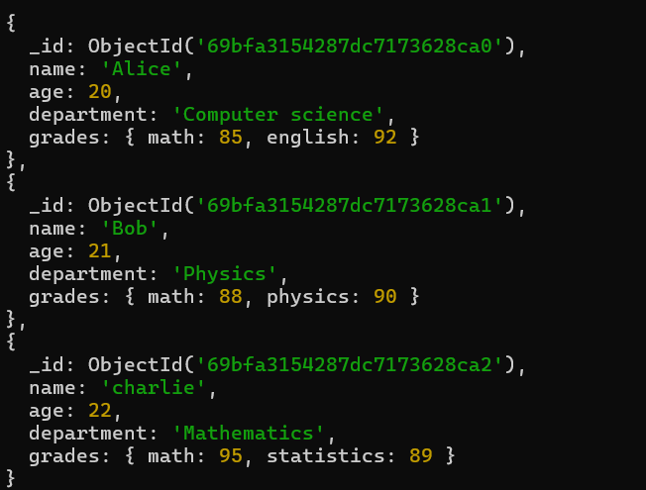
Q. (02) Write a query to display all students who are in the Computer Science department.
Query db. Student .find({department :"Computer science"})
Output
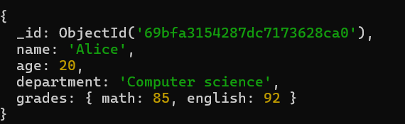

Q. (03) Write a query to update the grades of a student named Alice by adding a new subject programming with a grade of 93.
Query db.student.updateOne({name:"Alice"},{$set:{"grades.programming":93}})
Output

Query db. student. find()
Output
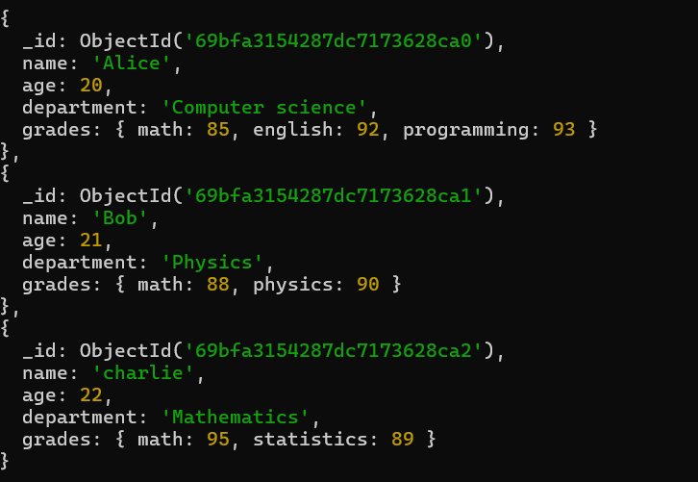

Q. (04) Write a query to increment the age of all students by 1.

Query db. student. Update Many({},{$inc :{age:1}})

Output
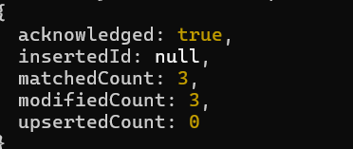
Query db. student. find()
Output
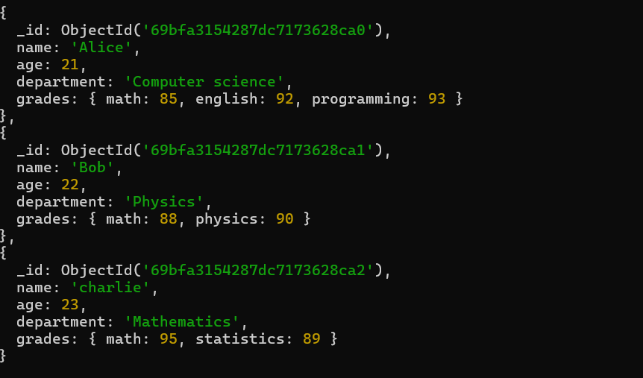
Q. (05) Write a query to delete all students who are 23 years old.

Query db. student. Delete Many({age:23})

Output
Query db. student. find()

Output
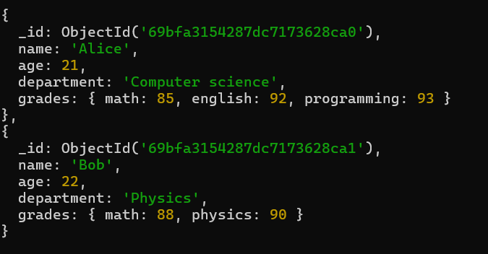

Q. (06) Write a query to create an index on the name field of the students collection.

Query db. student. Create Index({name:1})
Output

Query db. student. find()
Output
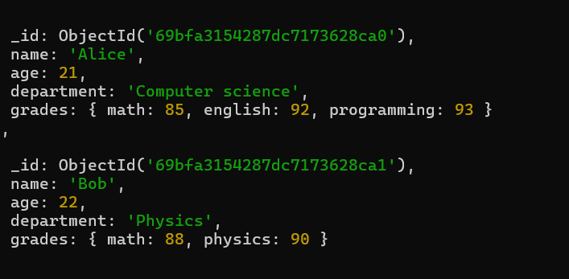

Q. (07) Write an aggregation query to group students by their department and calculate the average age in each department.

Query db.student.aggregate([{$group:{_id:"$department",averageAge:{$avg:"$age"}}}])
Output
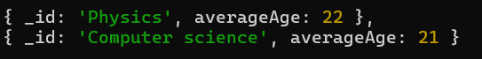

Q. (08) Write a query to find all students who have scored more than 90 in any subject.

Query db.student.find({$or:[{"grades.math":{$gt:90}},{"grades.english":{$gt:90}},{"grades.programming":{$gt:90}},{"grades.physics":{$gt:90}}]})
Output
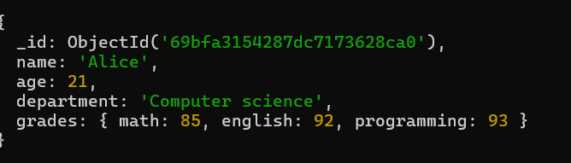

Q. (09) Write a query to add a new field graduated set to false for all students who are in the Mathematics department.

Query db.student.updateMany({"grades.math":{$exists:true}},{$set:{"graduated":false}})
Output
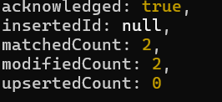
Query db. student. find()
Output
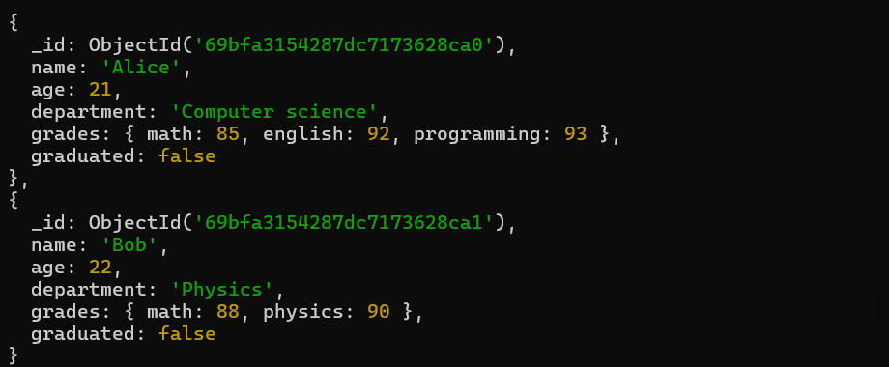

Q. (10) How can you retrieve only the name and department fields for all students, excluding the _id field?
Query db. student. find({},{name:1,department:1,_id:0})
Output

